Year 7 |  | Introductory Algebra | Non Calculator  Section
Skills and Knowledge Assessed:  - Introduce the concept of variables as a way of representing numbers using letters (ACMNA175)  - Extend and apply the laws and properties of arithmetic to algebraic terms and expressions (ACMNA177)  - Simplify algebraic expressions involving the four operations (ACMNA192) |  |  | Name___________________
Answer all questions in the spaces provided on this test paper by:
Writing the answer in the box provided.
or
Shading in the bubble for the correct answer from the four choices provided.
Show any working out on the test paper. Calculators are not allowed.
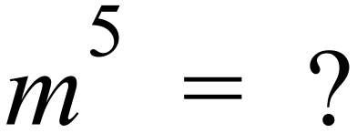
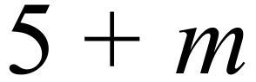
 | 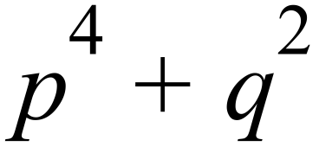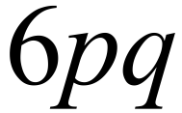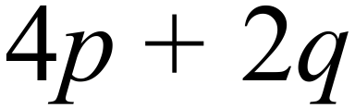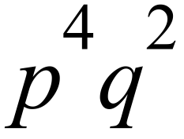
Ms Gausden asks her class to write an expression which is “Four times the square of m”
Which of these algebraic expressions could represent this?
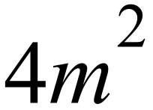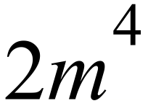
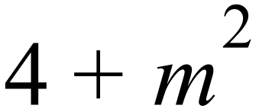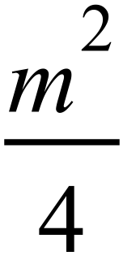
 | Simplify 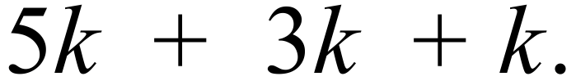
 | Simplify 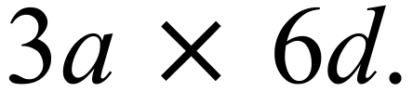
 | 1 2 6 37
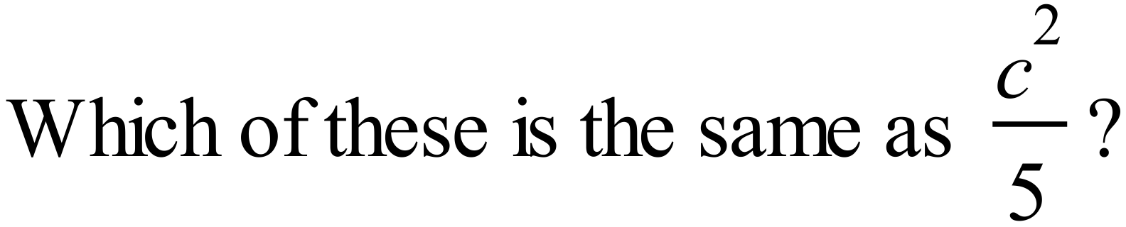

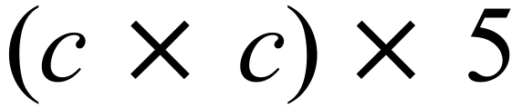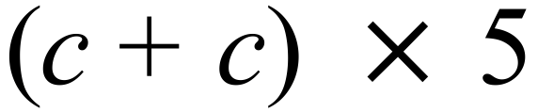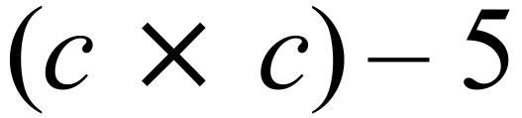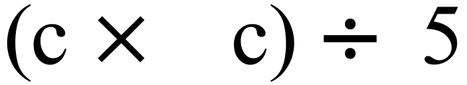
Which of these does not simplify to 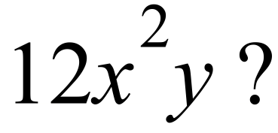

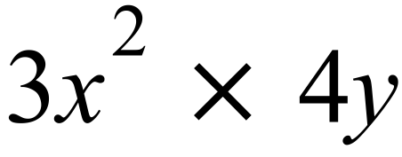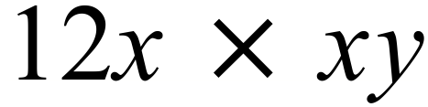
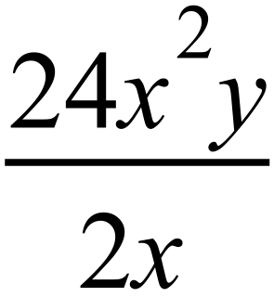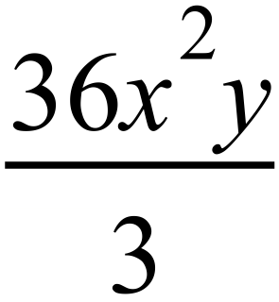
 | Simplify 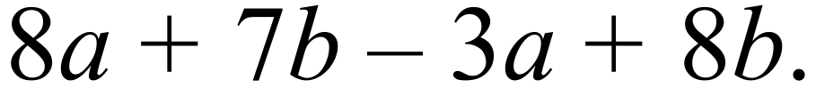
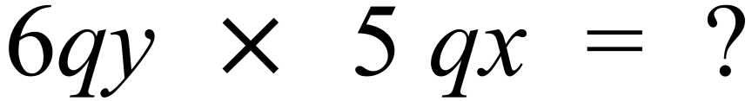

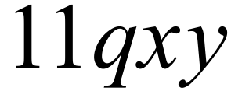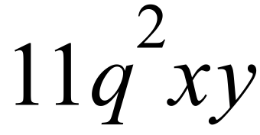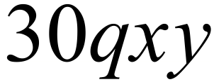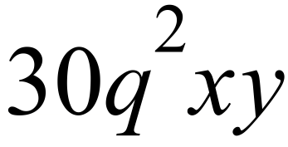
 | Simplify 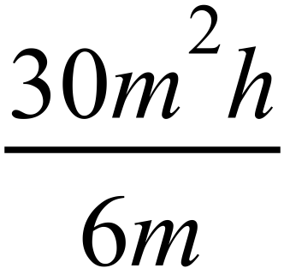
Simplify 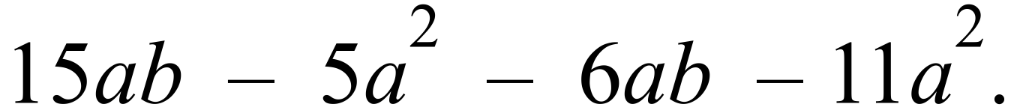

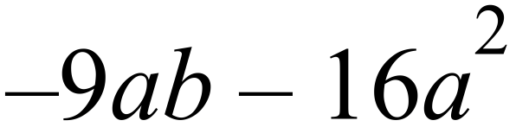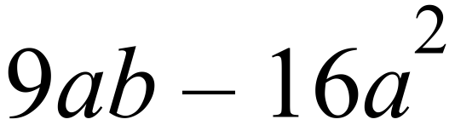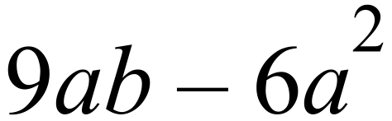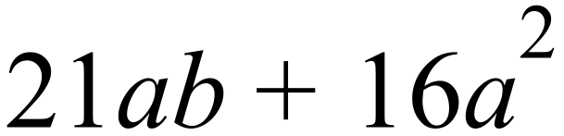
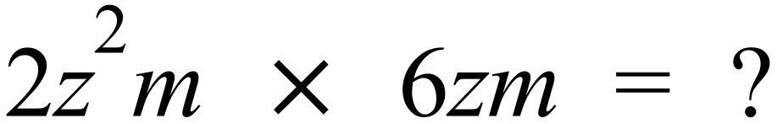

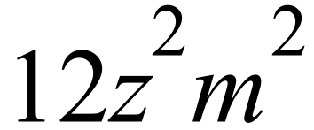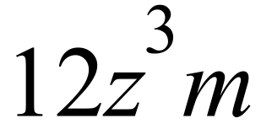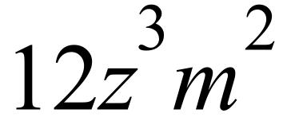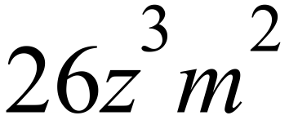
 | Simplify 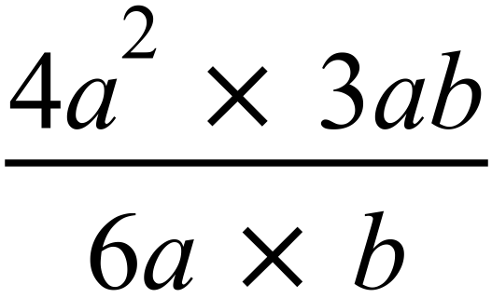 .
 | If a is an integer between 0 and 4 inclusive, what is the smallest value of 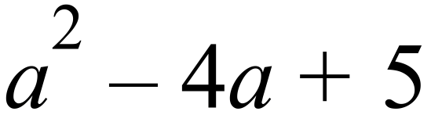 ?
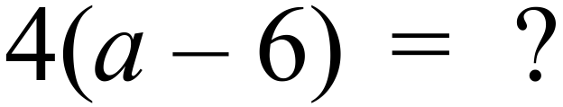

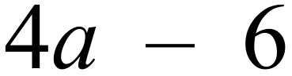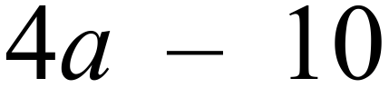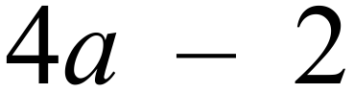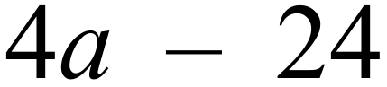
A cup holds x ml of water and a mug holds 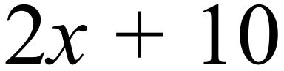 ml of water.
How much water does 3 cups and 2 mugs hold?

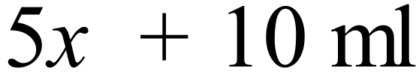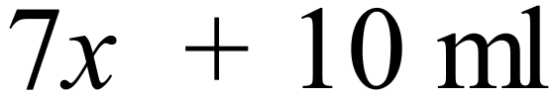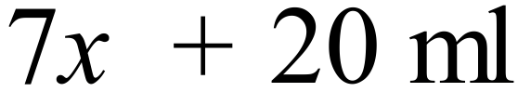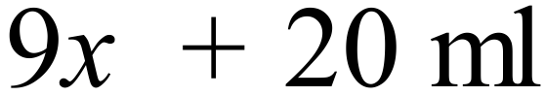
 | A rectangular sheet of plastic is l cm long and w cm wide. What is the combined area of 5 of these sheets?
Using n for the number, write an expression in algebraic symbols for the following.
“Take any number, double it and add five, then divide the result by 10.”

Year 7 |  | Introductory Algebra | Calculator Allowed  Short Answer  Section
 |  |  | Name___________________
Answer all questions in the spaces provided on this test paper by:
Writing the answer in the box provided.
or
Shading in the bubble for the correct answer from the four choices provided.
Show any working out on this test paper. Calculators are allowed.
 | Simplify 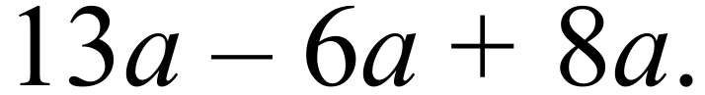
 | Simplify
 | If 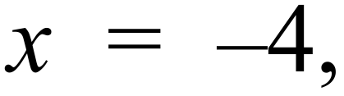 what is the value of 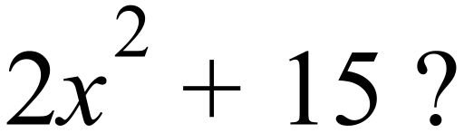
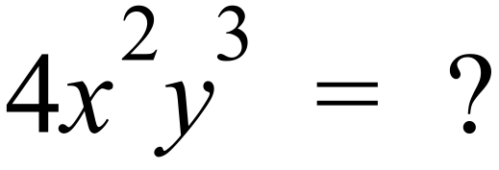

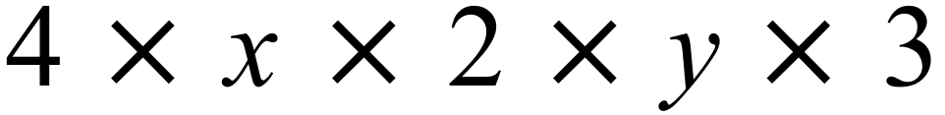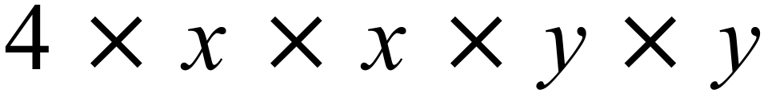
 | Write in index form.
If 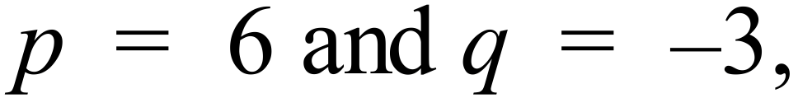 what is the value of 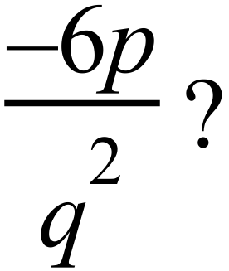

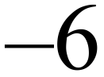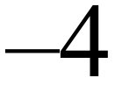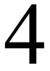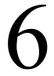
 | Write an albegraic expression for: “Multiply the sum of x and y by 4.”
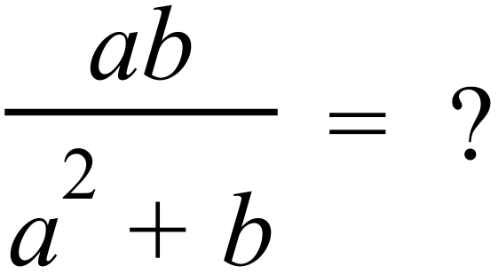

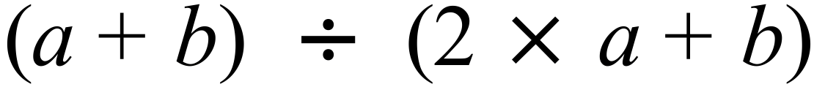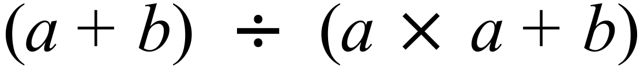
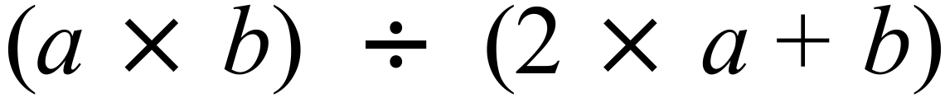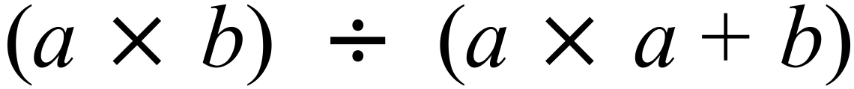
Which of the following does not simplify to give 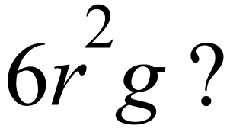

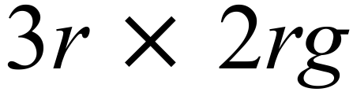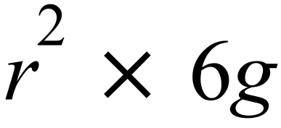
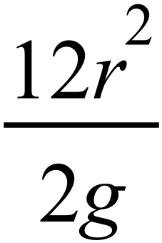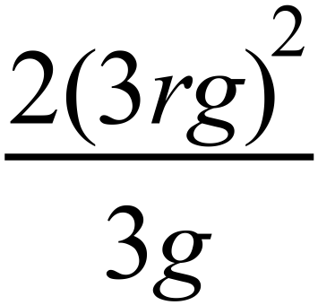
 | 9 22.5 30 90
Simplify

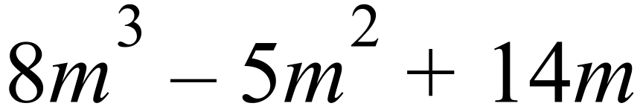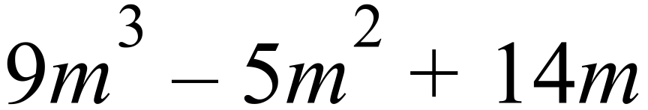
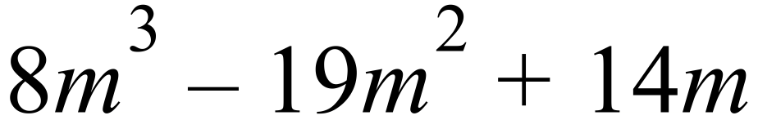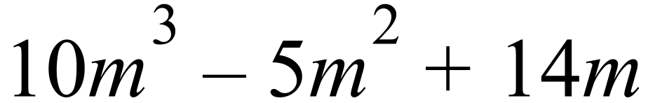
When 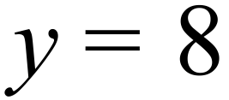 , 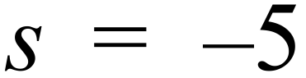 and 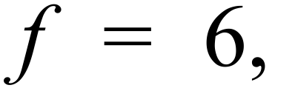 which expression has a value of 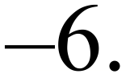

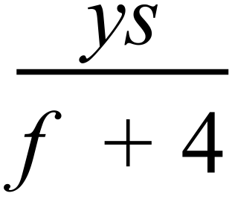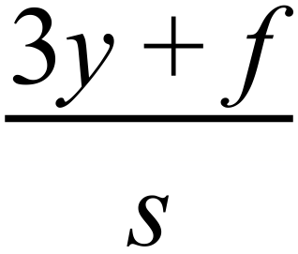
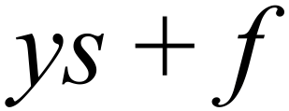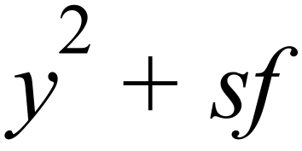
 | Simplify 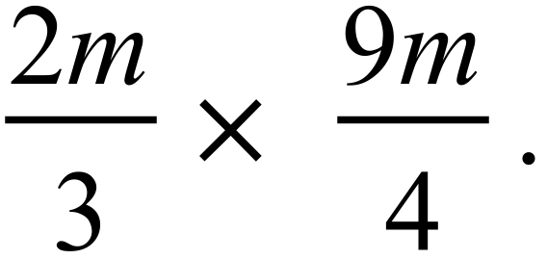
 | 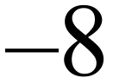 4 8
 | 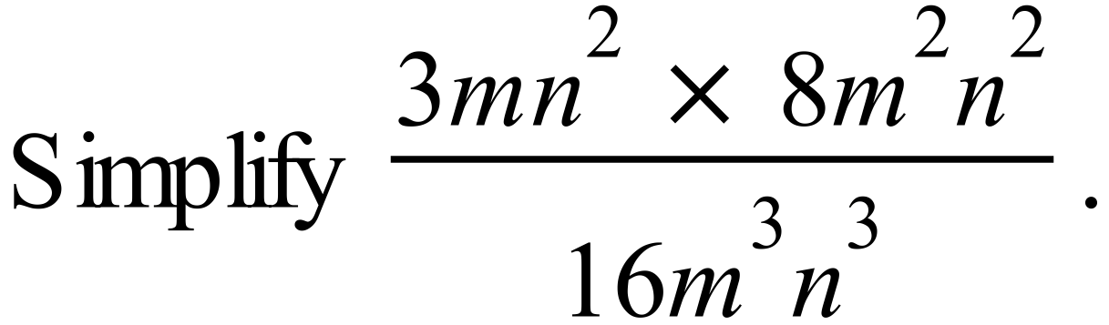
Which expression is not equal to 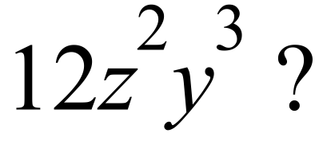
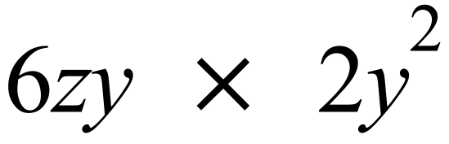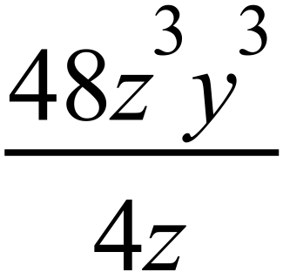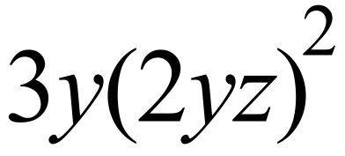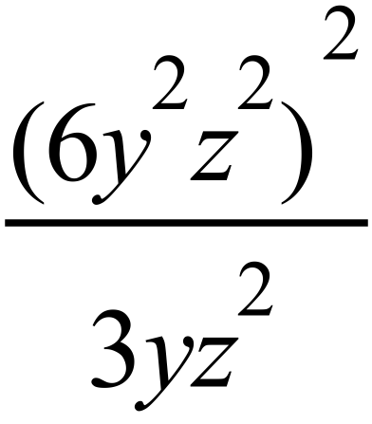
 | Which of these means the same as 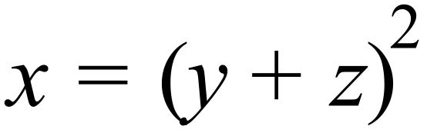
 | Which of these is always true, regardless of the values of a, b and c?

Year 7 |  | Introductory Algebra | Non Calculator  Section
ANSWERS
No. | WORKING |  | ANSWER
 |  |  | 2nd answer
 |  |  | 3rd answer
 |  |  | 1st answer
 | 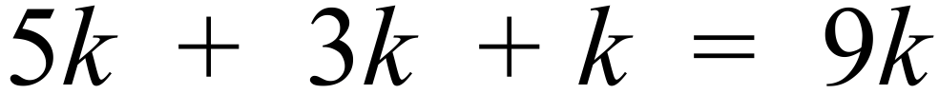 |  | 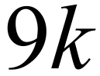
 | 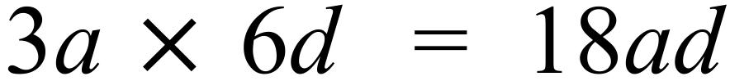 |  | 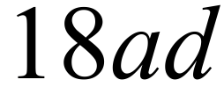
 | 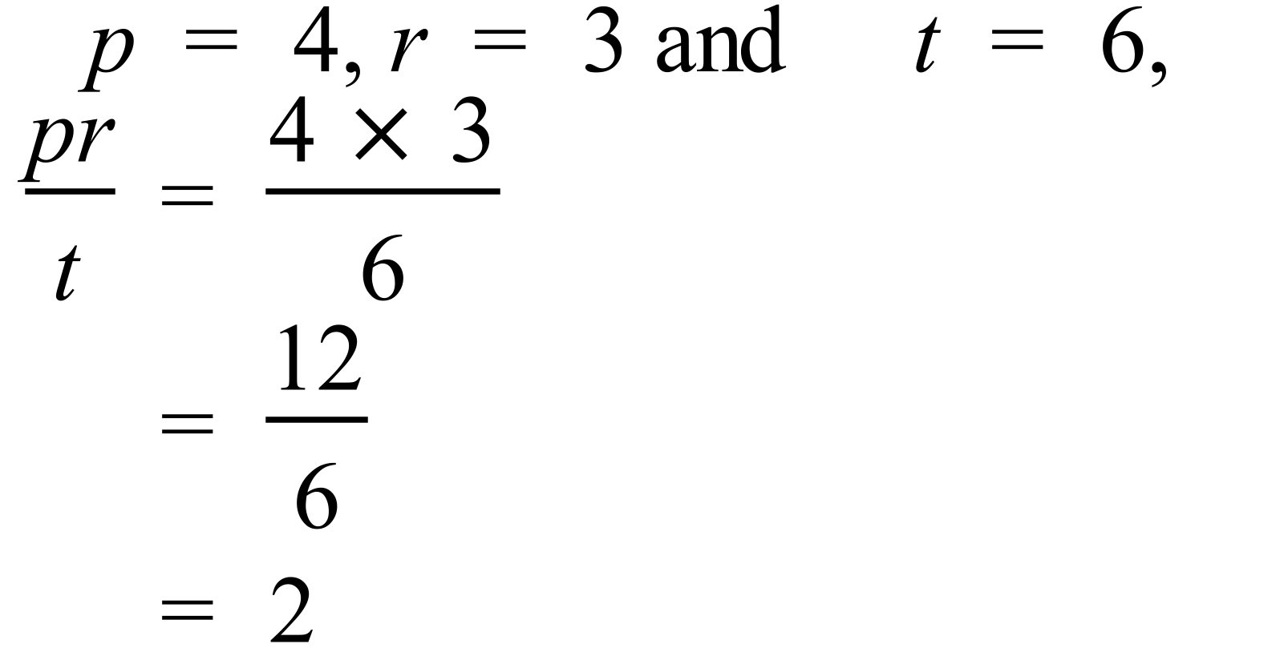 |  | 2nd answer
 | 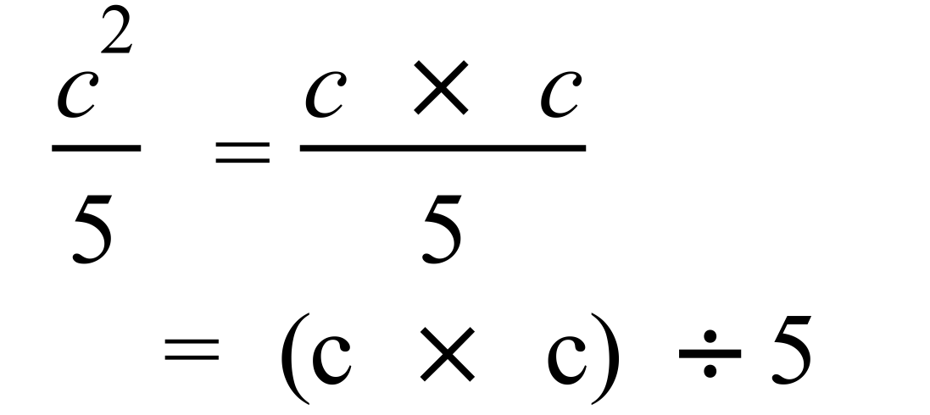 |  | 4th answer
 | 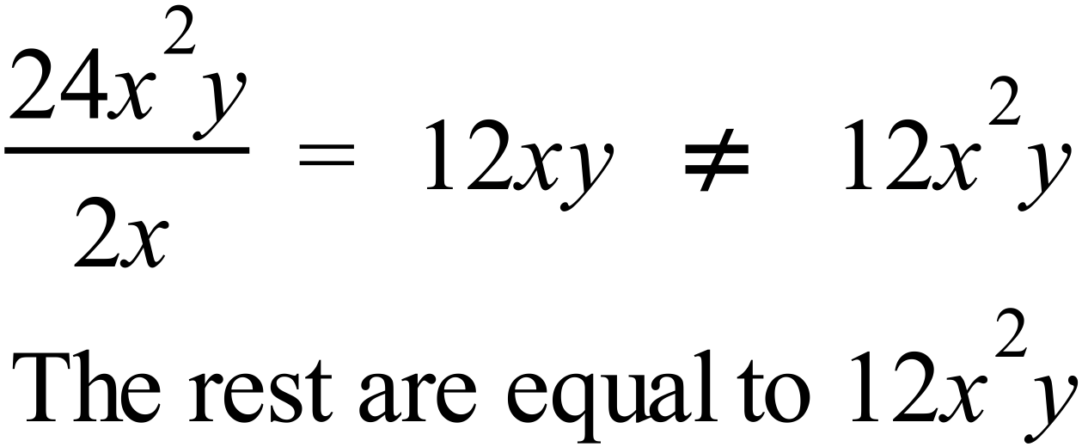 |  | 3rd answer
 |  |  | 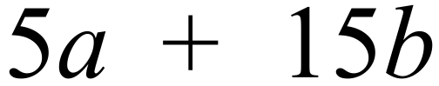
 | 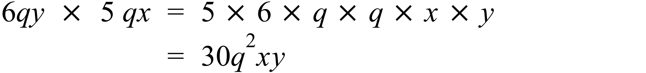 |  | 4th answer
 | 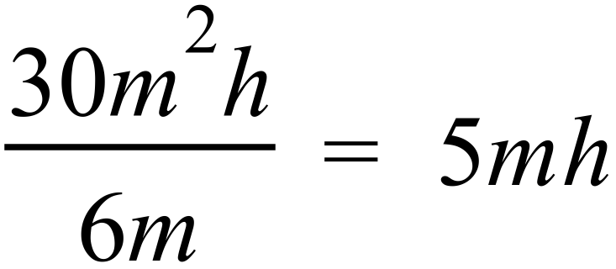 |  | 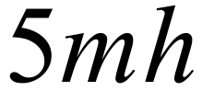
 |  |  | 2nd answer
 | 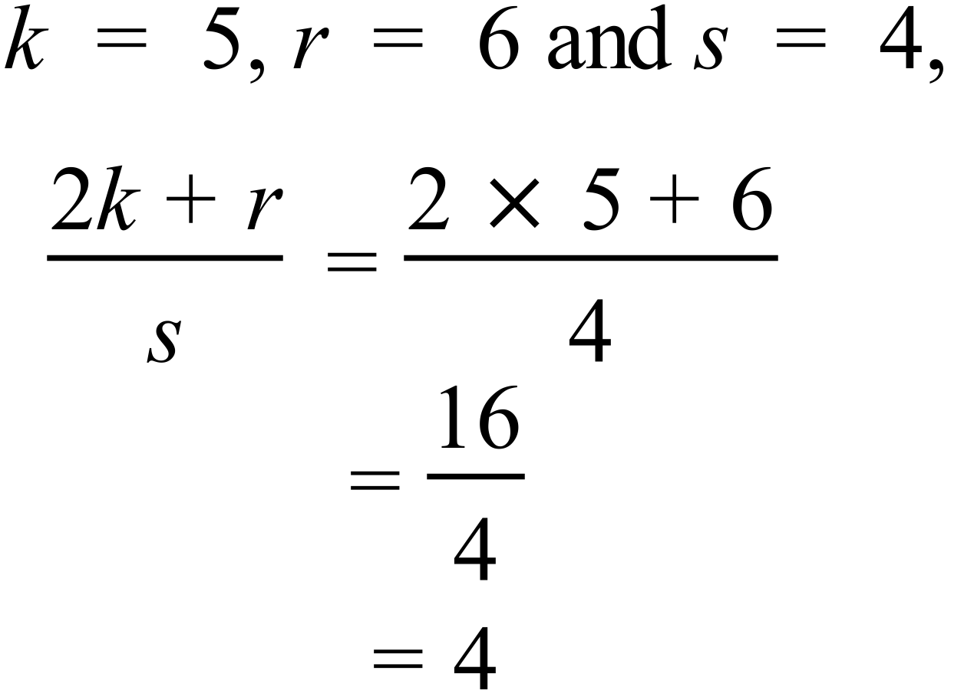 |  | 4
 | 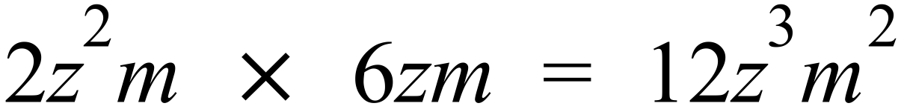 |  | 3rd answer
 | 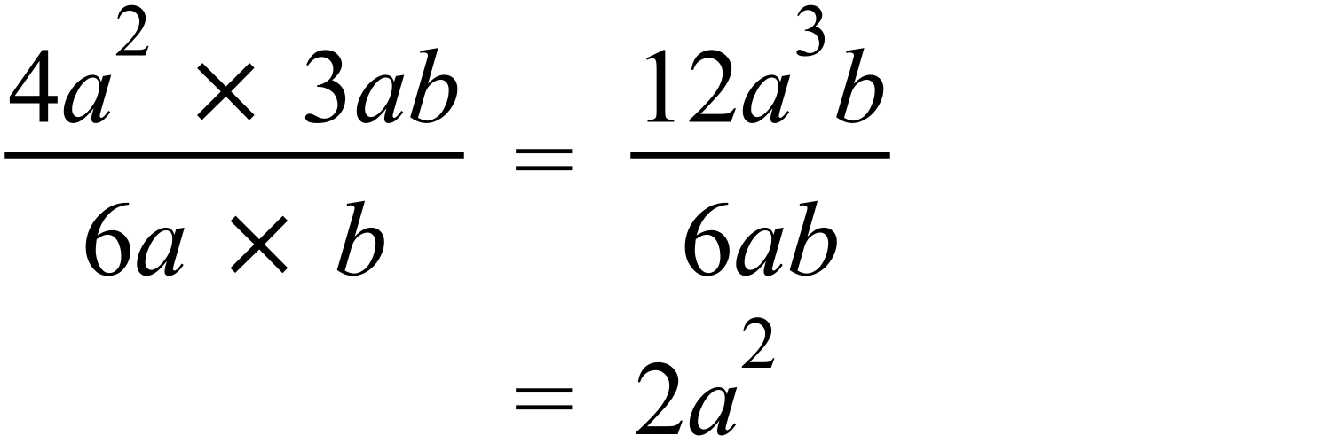 |  | 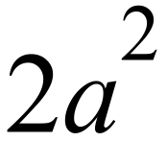
 | The smallest value is 1 |  | 1
  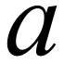
  0
  1
  2
  3
  4
 | 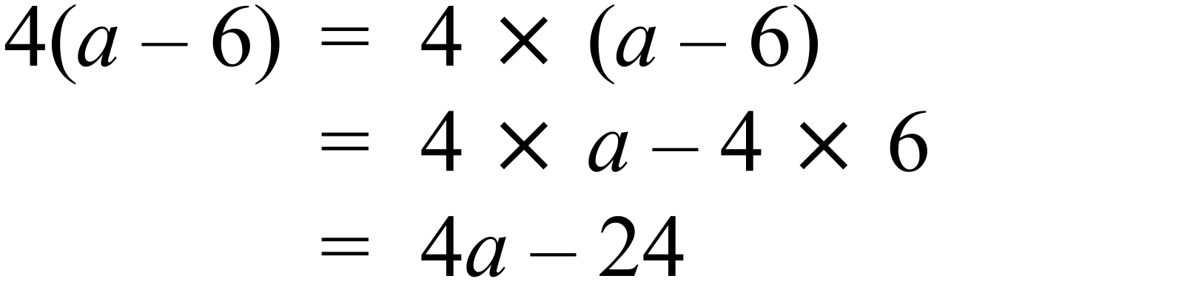 |  | 4th answer
 |  |  | 3rd answer
 | 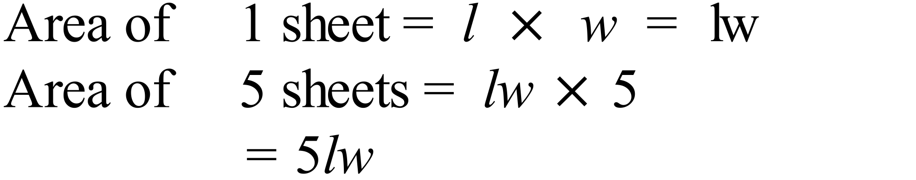 |  | 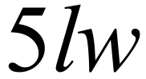
“Take any number (n)
Double it gives 2n
Add five, gives 2n + 5
Divide the result by 10 gives 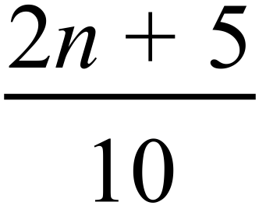

Year 7 |  | Introductory Algebra | Calculator Allowed  Short Answer  Section
ANSWERS
No. | WORKING |  |  | ANSWER
 |  |  |  | 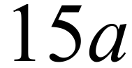
 |  |  |  | 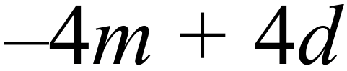
 | 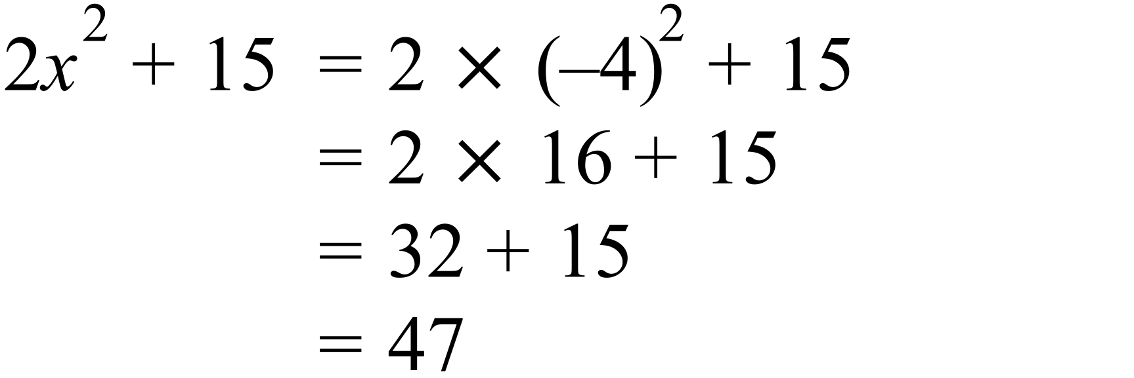 |  |  | 47
 | 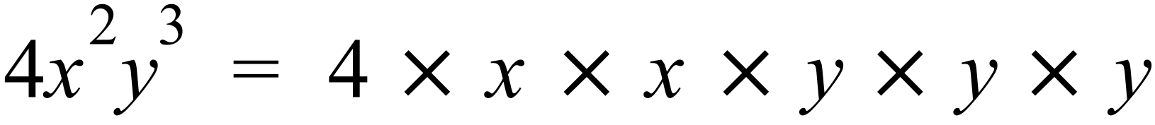 |  |  | 3rd answer
 |  |  |  | 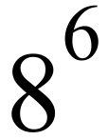
 | 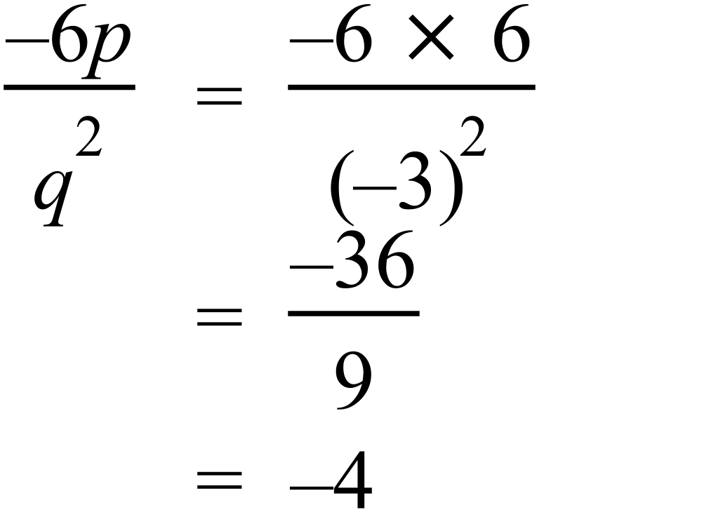 |  |  | 2nd answer
 | “Multiply the sum of x and y by 4.”  The sum of x and y = x + y  Multiply this by 4 = 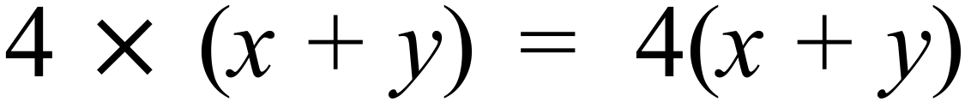 |  |  | 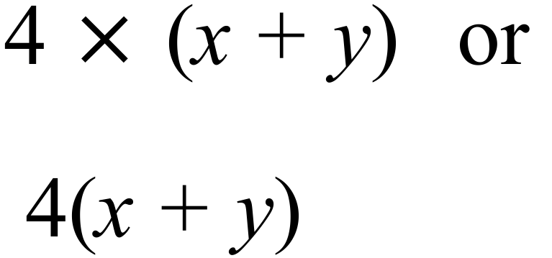
 | 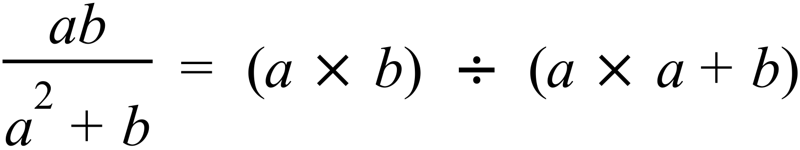 |  |  | 4th answer
 | 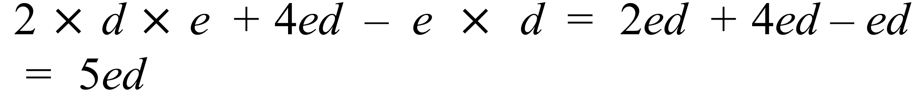 |  |  | 5ed or 5de
 | 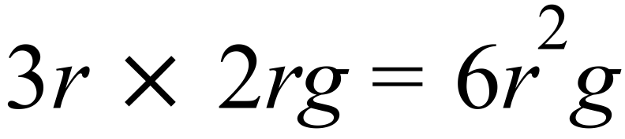  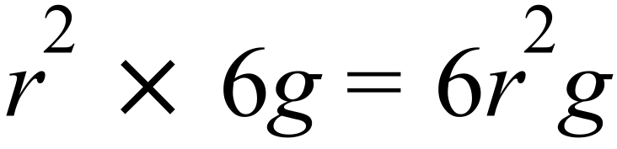  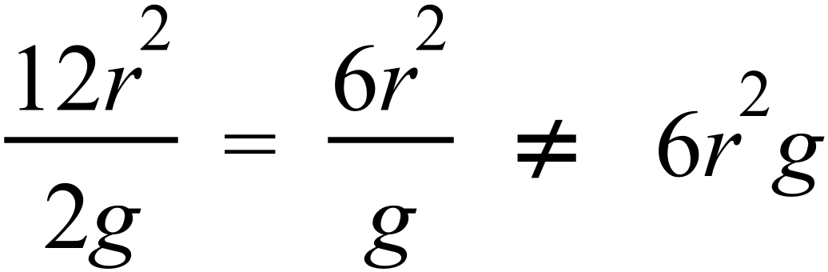  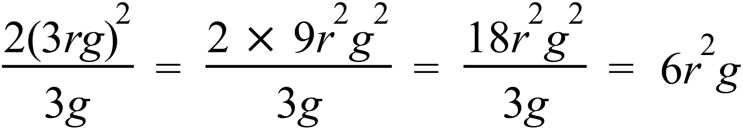 |  |  | 3rd answer
 | 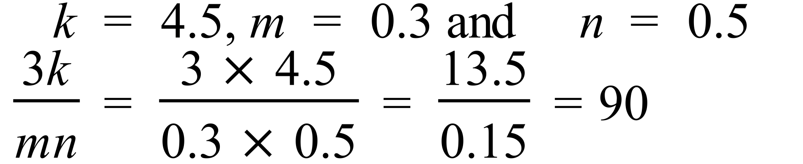 |  |  | 4th answer
 |  |  |  | 1st answer
 | , and 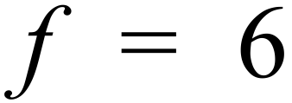  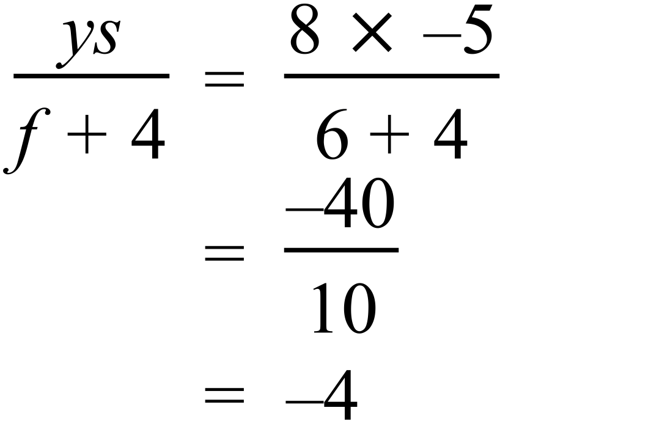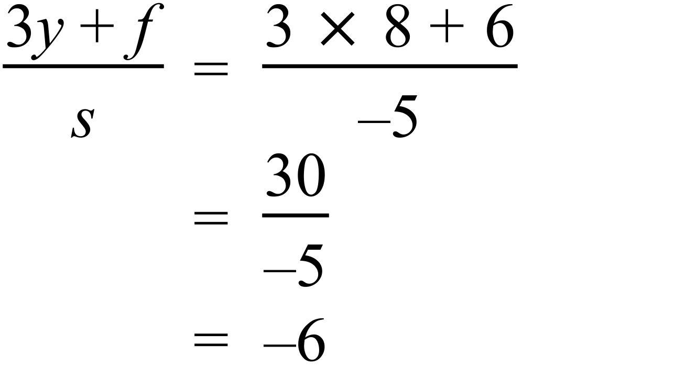  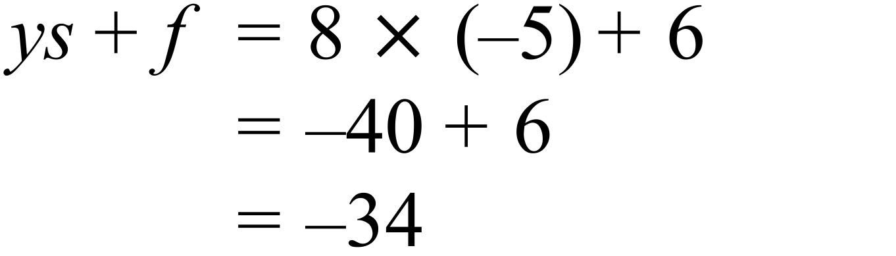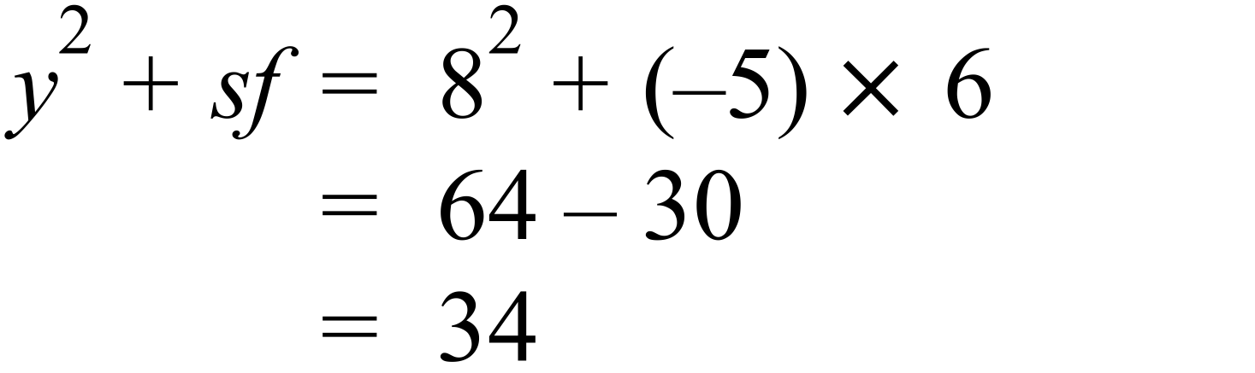 |  |  | 2nd answer
 | 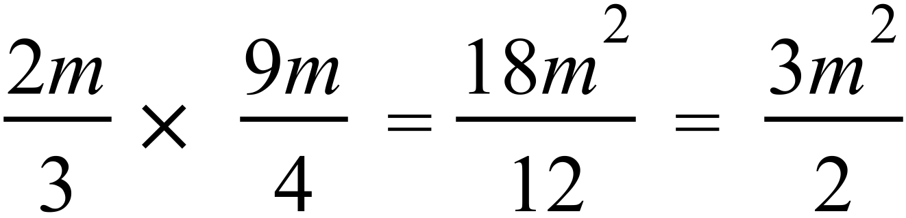 |  |  | 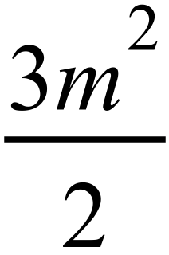
 | 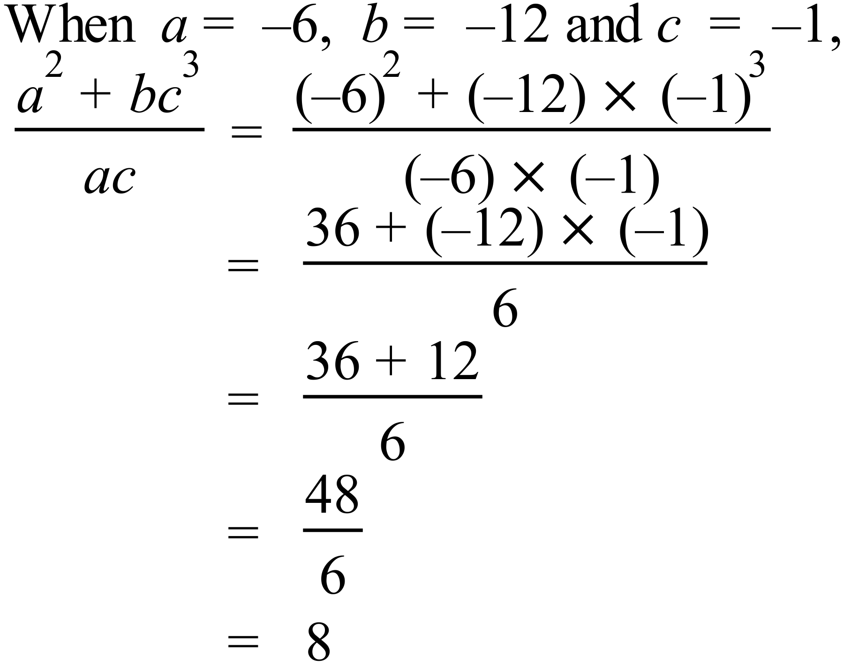 |  |  | 4th answer
 | 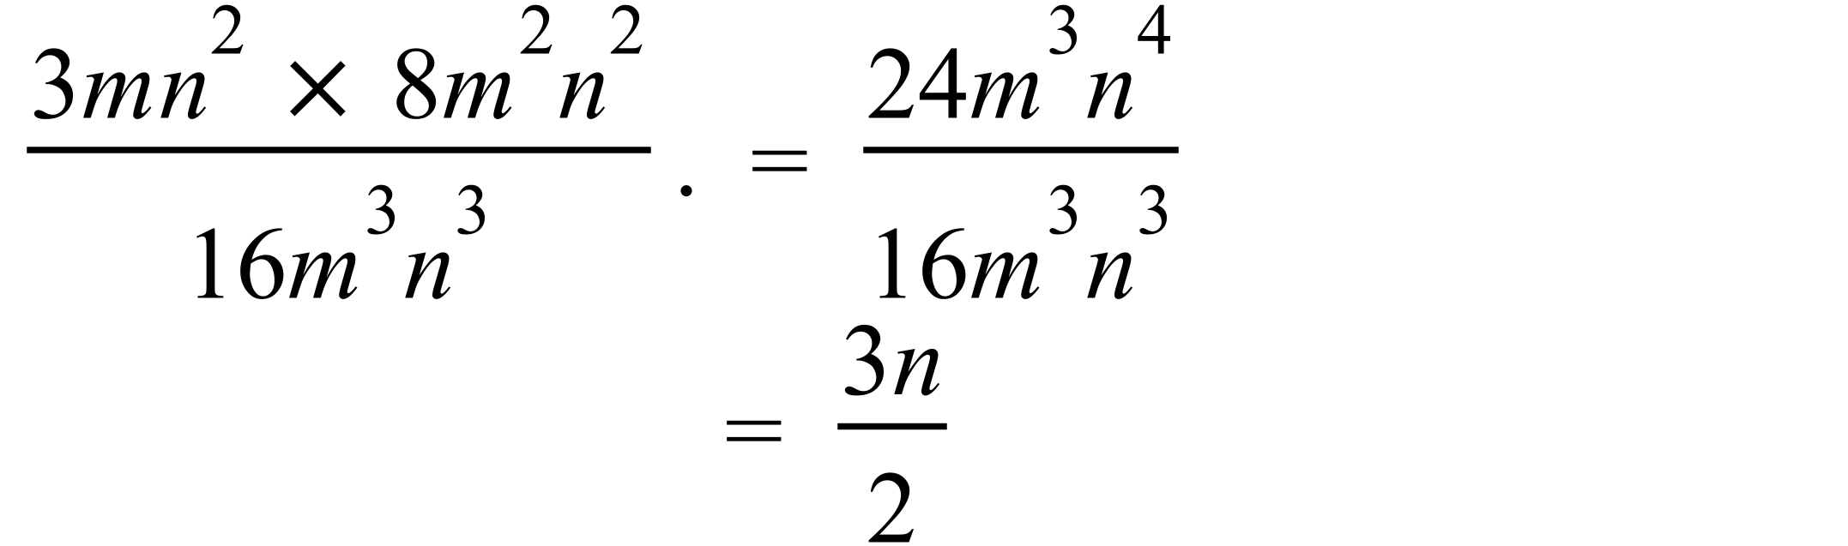 |  |  | 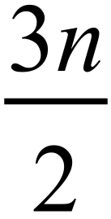
 | 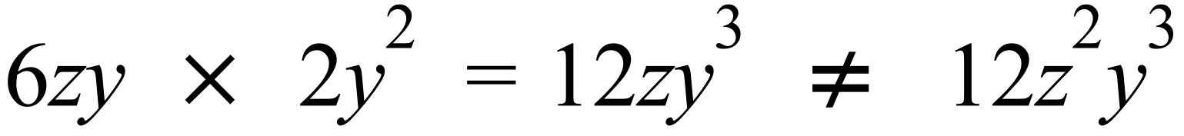  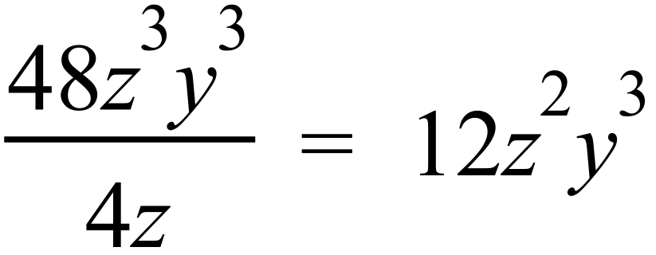  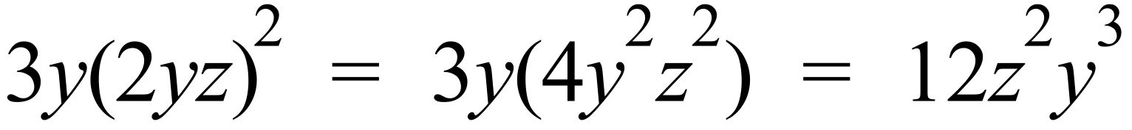  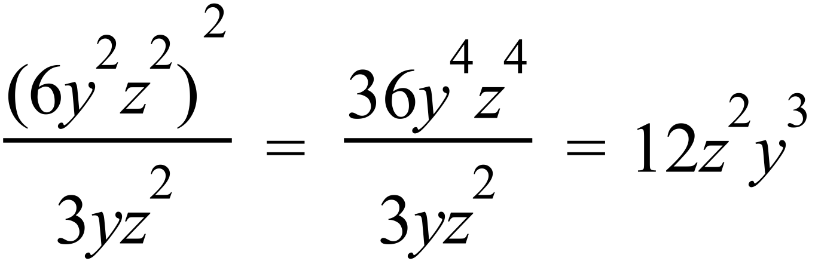 |  |  | 1st answer
 | 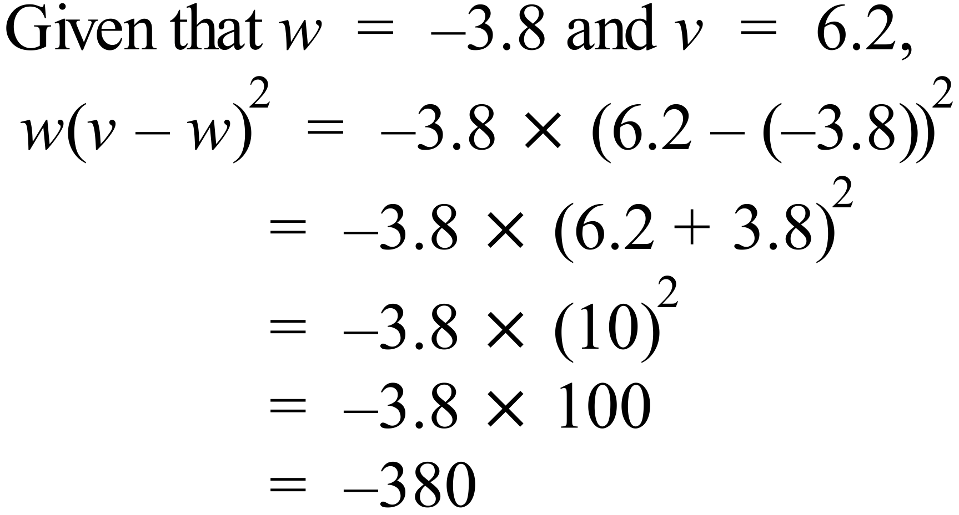 |  |  | 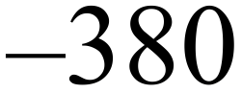
 |  |  |  | 1st answer
 | 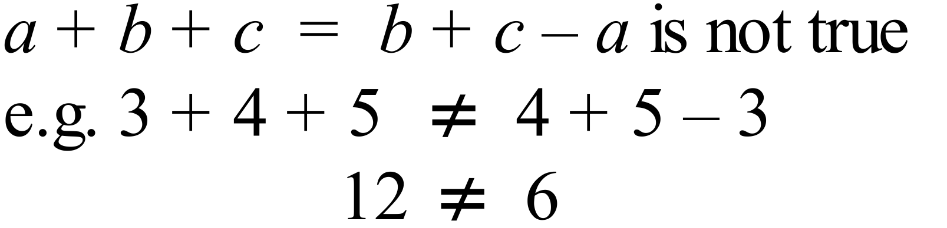  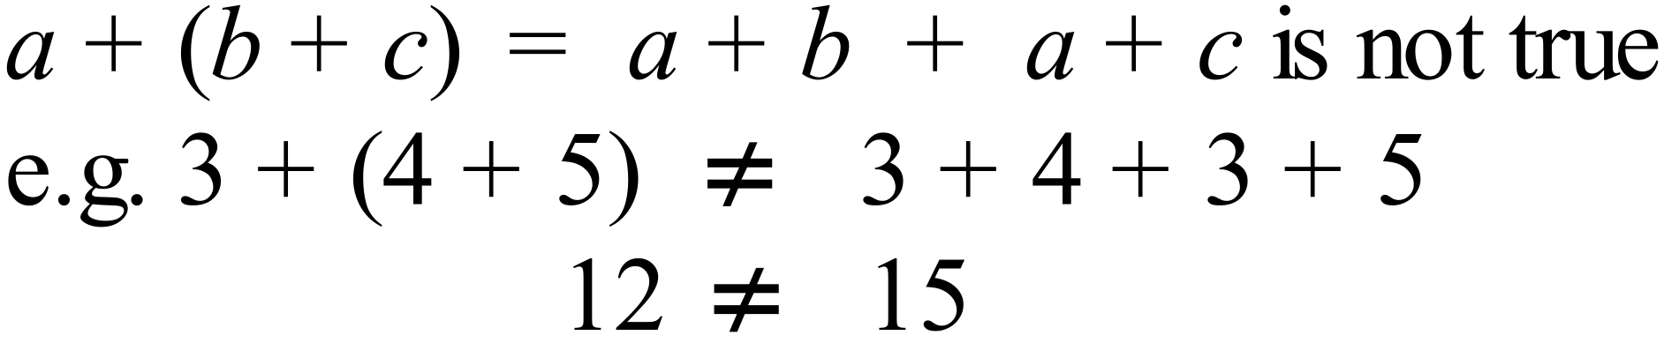  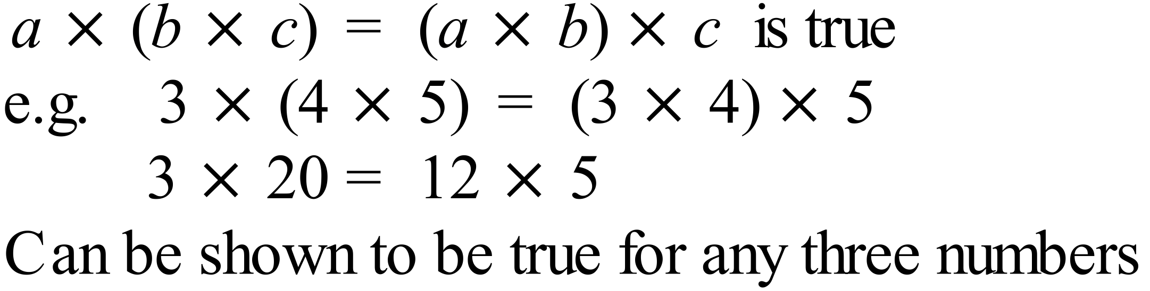  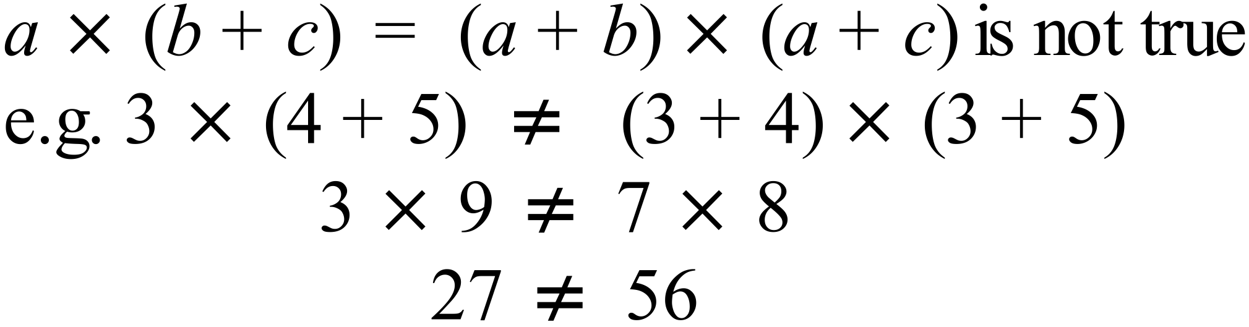 |  |  | 3rd answer

